Hemlibra®
Emicizumab

This medicinal product is subject to additional monitoring. This will allow quick identification of new safety information. Healthcare professionals are asked to report any suspected adverse reactions. See section 4.8 for how to report adverse reactions.

1. NAME OF THE MEDICINAL PRODUCT

Hemlibra 30 mg/mL solution for injection

Hemlibra 150 mg/mL solution for injection

2. QUALITATIVE AND QUANTITATIVE COMPOSITION

Hemlibra 30 mg/mL solution for injection

Each mL of solution contains 30 mg of emicizumab*

Each vial of 1 mL contains 30 mg of emicizumab at a concentration of 30 mg/mL.

Hemlibra 150 mg/mL solution for injection

Each mL of solution contains 150 mg of emicizumab*

Each vial of 0.4 mL contains 60 mg of emicizumab at a concentration of 150 mg/mL.

Each vial of 0.7 mL contains 105 mg of emicizumab at a concentration of 150 mg/mL.

Each vial of 1 mL contains 150 mg of emicizumab at a concentration of 150 mg/mL.

* Emicizumab is a humanised monoclonal modified immunoglobulin G4 (IgG4) antibody produced using recombinant DNA technology in mammalian Chinese Hamster Ovary (CHO) cells

For the full list of excipients, see section 6.1

3. PHARMACEUTICAL FORM

Solution for injection.

Colourless to slightly yellow solution.

4. CLINICAL PARTICULARS

4.1 Therapeutic indications

Hemlibra is indicated for routine prophylaxis of bleeding episodes in patients with
● haemophilia A (congenital factor VIII deficiency) with factor VIII inhibitors
● severe haemophilia A (congenital factor VIII deficiency, FVIII < 1%) without factor VIII inhibitors.

Hemlibra can be used in all age groups.

4.2 Posology and method of administration

Treatment should be initiated under the supervision of a physician experienced in the treatment of haemophilia and/or bleeding disorders.

Posology

Treatment (including routine prophylaxis) with bypassing agents (e.g. aPCC and rFVIIa) should be discontinued the day before starting Hemlibra therapy (see section 4.4).

Factor VIII (FVIII) prophylaxis may be continued for the first 7 days of Hemlibra treatment.

The recommended dose is 3 mg/kg once weekly for the first 4 weeks (loading dose), followed by maintenance dose of either 1.5 mg/kg once weekly, 3 mg/kg every two weeks, or 6 mg/kg every four weeks , all doses administered as a subcutaneous injection.

The loading dose regimen is the same, irrespective of the maintenance dose regimen.

The maintenance dose regimen should be selected based on physician and patient/caregiver dosing regimen preference to support adherence.

The patient dose (in mg) and volume (in mL) should be calculated as follows:

● Loading dose (3 mg/kg) once weekly for the first 4 weeks:
Patient bodyweight (kg) x dose (3 mg/kg) = total amount (mg) of emicizumab to be administered
● Followed by a maintenance dose of either 1.5 mg/kg once weekly, 3 mg/kg every two weeks or 6 mg/kg every four weeks, from week 5 on:
Patient bodyweight (kg) x dose (1.5; 3 or 6 mg/kg) = total amount (mg) of emicizumab to be administered

The total volume of Hemlibra to be injected subcutaneously is calculated as follows:
Total amount (mg) of emicizumab to be administered ÷ vial concentration (mg/mL) = total volume of Hemlibra (mL) to be injected.

Different Hemlibra concentrations (30 mg/mL and 150 mg/mL) should not be combined in the same syringe when making up the total volume to be administered.

A volume greater than 2 mL per injection should not be administered.

Examples:

Patient’s bodyweight of 16 kg, under a maintenance dose regimen of 1.5 mg/kg once weekly:
● Loading dose (first 4 weeks) example: 16 kg x 3 mg/kg = 48 mg of emicizumab needed for the loading dose.
● To calculate the volume to be administered divide calculated dose 48 mg by 150 mg/mL: 48 mg of emicizumab ÷ 150 mg/mL = 0.32 mL of 150 mg/mL Hemlibra concentration to be injected.
● Choose appropriate dosage and volume from vial strengths available.

● Maintenance dose (from week 5 on) example: 16 kg x 1.5 mg/kg = 24 mg of emicizumab needed for the maintenance dose.
● To calculate the volume to be administered divide calculated dose 24 mg by 30 mg/mL: 24 mg of emicizumab ÷ 30 mg/mL = 0.8 mL of 30 mg/mL Hemlibra concentration to be injected once weekly.
● Choose appropriate dosage and volume from vial strength available.

Patient’s bodyweight of 40 kg, under a maintenance dose regimen of 3 mg/kg every two weeks:
● Loading dose (first 4 weeks) example: 40 kg x 3 mg/kg = 120 mg of emicizumab needed for the loading dose.
● To calculate the volume to be administered divide calculated dose 120 mg by 150 mg/mL: 120 mg of emicizumab ÷ 150 mg/mL = 0.8 mL of 150 mg/mL Hemlibra concentration to be injected.
● Choose appropriate dosage and volume from vial strengths available.

● Maintenance dose (from week 5 on) example: 40 kg x 3 mg/kg = 120 mg of emicizumab needed for the maintenance dose.
● To calculate the volume to be administered divide calculated dose 120 mg by 150 mg/mL: 120 mg of emicizumab ÷ 150 mg/mL = 0.8 mL of 150 mg/mL Hemlibra concentration to be injected every two weeks.
● Choose appropriate dosage and volume from vial strength available.

Patient’s bodyweight of 60 kg, under a maintenance dose regimen of 6 mg/kg every four weeks:
● Loading dose (first 4 weeks) example: 60 kg x 3 mg/kg = 180 mg of emicizumab needed for the loading dose.
● To calculate the volume to be administered divide calculated dose 180 mg by 150 mg/mL: 180 mg of emicizumab ÷ 150 mg/mL = 1.20 mL of 150 mg/mL Hemlibra concentration to be injected.
● Choose appropriate dosage and volume from vial strengths available.

● Maintenance dose (from week 5 on) example: 60 kg x 6 mg/kg = 360 mg of emicizumab needed for the maintenance dose.
● To calculate the volume to be administered divide calculated dose 360 mg by 150 mg/mL: 360 mg of emicizumab ÷ 150 mg/mL = 2.4 mL of 150 mg/mL Hemlibra concentration to be injected every four weeks.
● Choose appropriate dosage and volume from vial strengths available.

Duration of treatment

Hemlibra is intended for long-term prophylactic treatment.

Dosage adjustments during treatment

No dosage adjustments of Hemlibra are recommended.

Delayed or missed doses

If a patient misses a scheduled subcutaneous injection of Hemlibra, the patient should be instructed to take the missed dose as soon as possible, up to a day before the day of the next scheduled dose. The patient should then administer the next dose on the usual scheduled dosing day. The patient should not take two doses on the same day to make up for a missed dose.

Special populations

Paediatric

No dose adjustments are recommended in paediatric patients (see section 5.2). There are no data in patients less than 1 year of age.

Elderly

No dose adjustments are recommended in patients ≥ 65 years of age (see sections 5.1 and 5.2). There are no data in patients over 77 years old.

Renal and hepatic impairment

No dose adjustments are recommended in patients with mild , renal or hepatic impairment (see section 5.2). There are limited data available on the use of Hemlibra in patients with moderate renal or hepatic impairment. Emicizumab has not been studied in patients with severe renal or hepatic impairment

Management in the perioperative setting

The safety and efficacy of emicizumab have not been formally evaluated in the surgical setting.
Patients have had surgical procedures without discontinuing emicizumab prophylaxis in clinical trials.

If bypassing agents (e.g. aPCC and rFVIIa) are required in the perioperative period, please refer to the dosing guidance on the use of bypassing agents in section 4.4.
If FVIII is required in the perioperative period, please refer to section 4.5.

When monitoring a patients underlying hemostatic activity, please refer to section 4.4 for laboratory tests unaffected by emicizumab.

Immune tolerance induction (ITI)

The safety and efficacy of emicizumab in patients receiving ongoing immune tolerance induction have not yet been established. No data are available.

Method of administration

Hemlibra is for subcutaneous use only, and it should be administered using appropriate aseptic technique (see section 6.6).

The injection should be restricted to the recommended injection sites: the abdomen, the upper outer arms and the thighs (see section 5.2).

Administration of Hemlibra subcutaneous injection in the upper outer arm should be performed by a caregiver or healthcare professional.

Alternating the site of injection may help prevent or reduce injection site reactions (see section 4.8). Hemlibra subcutaneous injection should not be administered into areas where the skin is red, bruised, tender or hard, or areas where there are moles or scars.

During treatment with Hemlibra, other medicinal products for subcutaneous administration should, preferably, be injected at different anatomical sites.

Administration by the patient and/or caregiver

Hemlibra is intended for use under the guidance of a healthcare professional. After proper training in subcutaneous injection technique, a patient may self-inject Hemlibra, or the patient’s caregiver may administer it, if their physician determines that it is appropriate.

The physician and the caregiver should determine the appropriateness of the child self-injecting Hemlibra. However, self-administration is not recommended for children below 7 years of age.

For comprehensive instructions on the administration of Hemlibra, see section 6.6 and package leaflet.

4.3 Contraindications

Hypersensitivity to the active substance or to any of the excipients listed in section 6.1.

4.4 Special warnings and precautions for use

Traceability

In order to improve traceability of biological medicinal products, the name and the batch number of the administered product should be clearly recorded.

Thrombotic microangiopathy associated with Hemlibra and activated prothrombin complex concentrate

Cases of thrombotic microangiopathy (TMA) were reported from a clinical trial in patients receiving Hemlibra prophylaxis when on average a cumulative amount of >100U/kg/24 hours of activated prothrombin complex concentrate (aPCC) for 24 hours or more was administered (see section 4.8). Treatment for the TMA events included supportive care with or without plasmapheresis and haemodialysis. Evidence of improvement was seen within one week following discontinuation of aPCC and interruption of Hemlibra. This rapid improvement is distinct from the usual clinical course observed in atypical hemolytic uremic syndrome and classic TMAs, such as thrombotic thrombocytopenic purpura (see section 4.8). One patient resumed Hemlibra following resolution of TMA and continued to be treated safely.

Patients receiving Hemlibra prophylaxis should be monitored for the development of TMA when administering aPCC. The physician should immediately discontinue aPCC and interrupt Hemlibra therapy if clinical symptoms and/or laboratory findings consistent with TMA occur, and manage as clinically indicated. Physicians and patients/caregivers should weigh the benefits and risks of resuming Hemlibra prophylaxis following complete resolution of TMA on a case-by-case basis. In case a bypassing agent is indicated in a patient receiving Hemlibra prophylaxis, see below for dosing guidance on the use of bypassing agents.

Caution should be used when treating patients who are at high risk for TMA (e.g. have a previous medical history or family history of TMA), or those who are receiving concomitant medications known to be a risk factor for the development of TMA (e.g. ciclosporin, quinine, tacrolimus).

Thromboembolism associated with Hemlibra and activated prothrombin complex concentrate

Serious thrombotic events were reported from a clinical trial in patients receiving Hemlibra prophylaxis when on average a cumulative amount of >100U/kg/24 hours of aPCC for 24 hours or more was administered (see section 4.8). No cases required anticoagulation therapy. Following discontinuation of aPCC and interruption of Hemlibra, evidence of improvement or resolution was seen within one month (see section 4.8). One patient resumed Hemlibra following resolution of thrombotic event and continued to be treated safely.

Patients receiving Hemlibra prophylaxis should be monitored for the development of thromboembolism when administering aPCC. The physician should immediately discontinue aPCC and interrupt Hemlibra therapy if clinical symptoms, imaging, and/or laboratory findings consistent with thrombotic events occur, and manage as clinically indicated. Physicians and patients/caregivers should weigh the benefits and risks of resuming Hemlibra prophylaxis following complete resolution of thrombotic events on a case-by-case basis. In case a bypassing agent is indicated in a patient receiving Hemlibra prophylaxis, see below for dosing guidance on the use of bypassing agents.

Guidance on the use of bypassing agents in patients receiving Hemlibra prophylaxis

Treatment with bypassing agents should be discontinued the day before starting Hemlibra therapy.

Physicians should discuss with all patients and/or caregivers the exact dose and schedule of bypassing agents to use, if required while receiving Hemlibra prophylaxis.

Hemlibra increases the patient’s coagulation potential. The bypassing agent dose required may therefore be lower than that used without Hemlibra prophylaxis. The dose and duration of treatment with bypassing agents will depend on the location and extent of bleeding, and the patient’s clinical condition. Use of aPCC should be avoided unless no other treatment options/alternatives are available. If aPCC is indicated in a patient receiving Hemlibra prophylaxis, the initial dose should not exceed 50 U/kg and laboratory monitoring is recommended (including but not restricted to renal monitoring, platelet testing, and evaluation of thrombosis). If bleeding is not controlled with the initial dose of aPCC up to 50 U/kg, additional aPCC doses should be administered under medical guidance or supervision with consideration made to laboratory monitoring for the diagnosis of TMA or thromboembolism and verification of bleeds prior to repeated dosing. The total aPCC dose should not exceed 100 U/kg in the first 24-hours of treatment. Treating physicians must carefully weigh the risk of TMA and thromboembolism against the risk of bleeding when considering aPCC treatment beyond a maximum of 100 U/kg in the first 24-hours.

In clinical trials, no cases of TMA or thrombotic events were observed with use of activated recombinant human FVII (rFVIIa) alone in patients receiving Hemlibra prophylaxis.

Bypassing agent dosing guidance should be followed for at least 6 months following discontinuation of Hemlibra prophylaxis (see section 5.2).

Effects of emicizumab on coagulation tests

Emicizumab restores the tenase cofactor activity of missing activated factor VIII (FVIIIa). Coagulation laboratory tests based on intrinsic clotting, including the activated clotting time (ACT), activated partial thromboplastin time (e.g. aPTT), measure the total clotting time including time needed for activation of FVIII to FVIIIa by thrombin. Such intrinsic pathway based tests will yield overly shortened clotting times with emicizumab, which does not require activation by thrombin. The overly shortened intrinsic clotting time will then disturb all single factor assays based on aPTT, such as the one stage FVIII activity assay (see section 4.4, Table 1). However, single factor assays utilising chromogenic or immuno-based methods are not affected by emicizumab and may be used to monitor coagulation parameters during treatment, with specific considerations for FVIII chromogenic activity assays as described below.

Chromogenic factor VIII activity tests may be manufactured with either human or bovine coagulation proteins. Assays containing human coagulation factors are responsive to emicizumab but may overestimate the clinical haemostatic potential of emicizumab. In contrast, assays containing bovine coagulation factors are insensitive to emicizumab (no activity measured) and can be used to monitor endogenous or infused factor VIII activity, or to measure anti FVIII inhibitors.

Emicizumab remains active in the presence of inhibitors against factor VIII and so will produce a false negative result in clotting based Bethesda assays for functional inhibition of factor VIII. Instead, a chromogenic Bethesda assay utilising a bovine based factor VIII chromogenic test that is insensitive to emicizumab may be used.

These two pharmacodynamic markers do not reflect the true haemostatic effect of emicizumab in vivo (aPTT is overly shortened and reported factor VIII activity may be overestimated) but provide a relative indication of the pro-coagulant effect of emicizumab.

In summary, intrinsic pathway clotting-based laboratory test results in patients treated with Hemlibra should not be used to monitor its activity, determine dosing for factor replacement or anti-coagulation, or measure factor VIII inhibitors titers. Caution should be taken if intrinsic pathway clotting based laboratory tests are used, as misinterpretation of their results may lead to under-treatment of patients experiencing bleeding episodes, which can potentially result in severe or life-threatening bleeds.

Laboratory tests affected and unaffected by emicizumab are shown in Table 1 below. Due to its long half-life, these effects on coagulation assays may persist for up to 6 months after the last dose (see section 5.2).

Table 1 Coagulation test results affected and unaffected by emicizumab

Results Affected by emicizumab | Results Unaffected by emicizumab
- Activated partial thromboplastin time (aPTT)  - Bethesda assays (clotting-based) for FVIII inhibitor titers  - One-stage, aPTT-based, single-factor assays  - aPTT-based activated protein C resistance (APC-R)  - Activated clotting time (ACT) | - Bethesda assays (bovine chromogenic) for FVIII inhibitor titers  - Thrombin time (TT)  - One-stage, prothrombin time (PT)-based, single-factor assays  - Chromogenic-based single-factor assays other than FVIII¹  - Immuno-based assays (e.g. ELISA, turbidimetric methods)  - Genetic tests of coagulation factors (e.g. Factor V Leiden, Prothrombin 20210)
¹For important considerations regarding FVIII chromogenic activity assays, see section 4.4.

Paediatric population

There are no data in children < 1 year of age. The developing hemostatic system in neonates and infants is dynamic and evolving, and the relative concentrations of pro- and anticoagulant proteins in these patients should be taken into consideration when making a benefit-risk assessment, including potential risk of thrombosis (e.g. central venous catheter-related thrombosis).

4.5 Interaction with other medicinal products and other forms of interaction

No adequate or well-controlled drug-drug interaction studies have been conducted with emicizumab.

Clinical experience indicates a drug interaction exists with emicizumab and aPCC (see sections 4.4 and 4.8).

There is a possibility for hypercoagulability with rFVIIa or FVIII with emicizumab based on preclinical experiments. Emicizumab increases coagulation potential, therefore the FVIIa or FVIII dose required to achieve hemostasis may be lower than when used without Hemlibra prophylaxis.

In case of thrombotic complication, the physician should consider discontinuing rFVIIa or FVIII and interrupt Hemlibra prophylaxis as clinically indicated. Further management should be tailored to the individual clinical circumstances.
● Decision about dose modifications should take into account the half-life of medications; specifically, interruption of emicizumab may not have an immediate effect.
● Monitoring using a FVIII chromogenic assay may guide the administration of coagulation factors, and testing for thrombophilic traits may be considered.

Experience with concomitant administration of anti-fibrinolytics with aPCC or rFVIIa in patients receiving Hemlibra prophylaxis is limited. However, the possibility of thrombotic events should be considered when systemic anti-fibrinolytics are used in combination with aPCC or rFVIIa in patients receiving emicizumab.

4.6 Fertility, pregnancy and lactation

Women of childbearing potential/Contraception

Women of childbearing potential receiving Hemlibra should use effective contraception during, and for at least 6 months after cessation of Hemlibra treatment (see section 5.2).

Pregnancy

There are no clinical studies of emicizumab use in pregnant women. Animal reproduction studies have not been conducted with Hemlibra. It is not known whether emicizumab can cause fetal harm when administered to a pregnant woman or can affect reproductive capacity. Hemlibra should be used during pregnancy only if the potential benefit for the mother outweighs the potential risk to the fetus taking into account that, during pregnancy and after parturition, the risk for thrombosis is increased and that several pregnancy complications are linked to an increased risk for disseminated intravascular coagulation (DIC).

Breast-feeding

It is not known whether emicizumab is excreted in human milk. No studies have been conducted to assess the impact of emicizumab on milk production or its presence in breast milk. Human IgG is known to be present in human milk. A decision must be made whether to discontinue breast-feeding or to discontinue/abstain from Hemlibra therapy taking into account the benefit of breast-feeding for the child and the benefit of therapy for the woman.

Fertility

Animal studies do not indicate direct or indirect harmful effects with respect to reproductive toxicity (see section 5.3). No fertility data are available in humans. Thus, the effect of emicizumab on male and female fertility is unknown.

4.7 Effects on ability to drive and use machines

Hemlibra has no influence on the ability to drive and use machines.

4.8 Undesirable effects

Summary of the safety profile

The most serious adverse drug reactions (ADRs) reported from the clinical trials with Hemlibra were thrombotic microangiopathy (TMA) and thrombotic events, including cavernous sinus thrombosis (CST) and superficial vein thrombosis contemporaneous with skin necrosis (see below and section 4.4).

The most common ADRs reported in ≥ 10% of patients treated with at least one dose of Hemlibra were: injection site reactions (20 %), arthralgia (15 %) and headache (14 %).

In total three patients (0.8 %) in the clinical trials receiving Hemlibra prophylaxis withdrew from treatment due to ADRs, which were TMA, skin necrosis contemporaneous with superficial thrombophlebitis, and headache.

Tabulated list of adverse drug reactions

The following adverse drug reactions (ADRs) are based on pooled data from four phase III clinical trials (adult and adolescent studies [BH29884 - HAVEN 1, BH30071 – HAVEN 3, and BO39182 – HAVEN 4] and a paediatric study BH29992 - HAVEN 2]), in which a total of 373 male patients with haemophilia A received at least one dose of Hemlibra as routine prophylaxis. Two hundred and sixty-six (71 %) were adults, 47(13 %) were adolescents (≥ 12 to < 18 years), 55 (15 %) were children (≥ 2 to < 12 years) and five (1 %) were infants and toddlers (1 month to < 2 years). The median duration of exposure across the studies was 33 weeks (range: 0.1 to 94.3 weeks).

ADRs from the phase III clinical trials in patients who received Hemlibra are listed by MedDRA system organ class (Table 2). The corresponding frequency categories for each ADR are based on the following convention: very common (≥ 1/10), common (≥ 1/100 to < 1/10), uncommon (≥ 1/1,000 to < 1/100), rare (≥ 1/10,000 to < 1/1,000), very rare (< 1/10,000) and not known (cannot be estimated from the available data).

Table 2 Summary of adverse drug reactions from pooled HAVEN clinical trials with Hemlibra

System Organ Class (SOC) | Adverse reactions  (preferred term, MedDRA) | Frequency
Blood and lymphatic system disorders | Thrombotic microangiopathy | Uncommon
Nervous system disorders | Headache | Very common
Vascular disorders | Thrombophlebitis superficial | Uncommon
 | *Cavernous sinus thrombosis | Uncommon
Gastrointestinal disorders | Diarrhoea | Common
Skin and subcutaneous tissue disorders | Skin necrosis | Uncommon
Musculoskeletal and connective tissue disorders | Arthralgia | Very common
 | Myalgia | Common
General disorders and administration site conditions | Injection site reaction | Very common
 | Pyrexia | Common
*Vascular disorders is a secondary SOC for cavernous sinus thrombosis.

Description of selected adverse drug reactions

Thrombotic microangiopathy

In pooled phase III clinical trials, thrombotic microangiopathy (TMA) events were reported in less than 1 % of patients (3/373) and in 9.7 % of patients (3/31) who received at least one dose of aPCC while being treated with emicizumab. All 3 TMAs occurred when on average a cumulative amount of > 100 U/Kg/24 hours of aPCC for 24 hours or more was administered during a treatment event (see section 4.4). Patients presented with thrombocytopenia, microangiopathic hemolytic anemia, and acute kidney injury, without severe deficiencies in ADAMTS13 activity. One patient resumed Hemlibra following resolution of TMA without recurrence.

Thrombotic events

In pooled phase III clinical trials, serious thrombotic events were reported in less than 1 % of patients (2/373) and in 6.5 % of patients (2/31) who received at least one dose of aPCC while being treated with emicizumab. Both serious thrombotic events occurred when on average a cumulative amount of > 100 U/Kg/24 hours of aPCC for 24 hours or more was administered during a treatment event. One patient resumed Hemlibra following resolution of the thrombotic event without recurrence (see section 4.4).

Characterization of the interaction between emicizumab and aPCC treatment in pivotal clinical trials

There were 82 instances of aPCC treatment* in patients receiving Hemlibra prophylaxis, of which eight instances (10%) consisted of on average a cumulative amount of >100 U/kg/24 hours of aPCC for 24 hours or more; two of the eight instances were associated with thrombotic events and three of the eight instances were associated with TMA (Table 3). No TMA or thrombotic events were associated with the remaining instances of aPCC treatment. Of all instances of aPCC treatment, 68 % consisted of only one infusion < 100 U/kg.

Table 3 Characterisation of aPCC treatment* in the pooled phase III clinical studies

Duration of aPCC treatment | Average cumulative amount of aPCC over 24 hours (U/kg/24 hours)
 | <50 | 50–100 | >100
<24 hours | 9 | 47 | 13
24-48 hours | 0 | 3 | 1^{b}
>48 hours | 1 | 1 | 7^{a,a,a,b}

* An instance of aPCC treatment is defined as all doses of aPCC received by a patient, for any reason, until there was a 36-hour treatment-free break. Includes all instances of aPCC treatment excluding those in the first 7 days and those that occurred 30 days after the discontinuation of Hemlibra.
ª Thrombotic microangiopathy
^{b} Thrombotic event

Injection site reactions

Injection site reactions (ISRs) were reported very commonly (20 %) from clinical trials. All ISRs observed in the Hemlibra clinical trials were reported as being non-serious and mild to moderate in intensity, and 95 % resolved without treatment. The most commonly reported ISR symptoms were injection site erythema (11 %), injection site pain (4 %) and injection site pruritus (3 %).

Paediatric population

The paediatric population studied comprises a total of 107 patients, of which 5 (5 %) were infants and toddlers (1 month to less than 2 years of age), 55 (51 %) were children (from 2 to less than 12 years of age) and 47 (44 %) were adolescents (from 12 to less than 18 years old). The safety profile of Hemlibra was overall consistent between infants, children, adolescents, and adults.

Reporting of suspected adverse reactions

Reporting suspected adverse reactions after authorisation of the medicinal product is important. It allows continued monitoring of the benefit/risk balance of the medicinal product.

4.9 Overdose

There is limited experience with overdose of Hemlibra.

Symptoms

Accidental overdose may result in hypercoagulability.

Management

Patients who receive an accidental overdose should immediately contact their physician and be monitored closely.

5. PHARMACOLOGICAL PROPERTIES

5.1 Pharmacodynamic properties

Pharmacotherapeutic group: antihemorrhagics, other systemic hemostatics; ATC code: B02BX06

Mechanism of action

Emicizumab is a humanized monoclonal modified immunoglobulin G4 (IgG4) antibody with a bispecific antibody structure.

Emicizumab bridges activated factor IX and factor X to restore the function of missing activated factor VIII that is needed for effective haemostasis.

Emicizumab has no structural relationship or sequence homology to factor VIII and, as such, does not induce or enhance the development of direct inhibitors to factor VIII.

Pharmacodynamics

Prophylactic therapy with Hemlibra shortens the aPTT and increases the reported factor VIII activity (using a chromogenic assay with human coagulation factors). These two pharmacodynamic markers do not reflect the true haemostatic effect of emicizumab in vivo (aPTT is overly shortened and reported factor VIII activity may be overestimated) but provide a relative indication of the pro-coagulant effect of emicizumab.

Clinical efficacy and safety

The efficacy of Hemlibra for routine prophylaxis in patients with hemophilia A with or without FVIII inhibitors was evaluated in four clinical studies (three adult and adolescent studies [HAVEN 3, HAVEN 1, and HAVEN 4] and a paediatric study [HAVEN 2]).

Clinical studies in adults and adolescents

Patients (aged ≥ 12 years old and > 40 kg) with hemophilia A without FVIII inhibitors (Study BH30071 – HAVEN 3)

The HAVEN 3 study was a randomized, multicenter, open-label, phase III clinical study in 152 adult and adolescent males (aged ≥ 12 years and > 40 kg) with severe hemophilia A without FVIII inhibitors who previously received either episodic (“on demand”) or prophylactic treatment with FVIII. Patients received subcutaneous Hemlibra, 3 mg/kg once weekly for the first four weeks followed by either 1.5 mg/kg once weekly (Arms A and D) or 3 mg/kg every two weeks (Arm B) thereafter, or no prophylaxis (Arm C). Patients in Arm C could switch to Hemlibra (3 mg/kg every two weeks) after completing at least 24 weeks without prophylaxis. For Arms A and B dose up-titration to 3 mg/kg weekly was allowed after 24 weeks for patients who experienced two or more qualified bleeds (i.e., spontaneous and clinically significant bleeds occurring at steady state). Arm D patients could up-titrate after the second qualifying bleed. At the time of the primary analysis, five patients underwent up-titration of their maintenance dose.

Eighty-nine patients previously treated with episodic (“on demand”) FVIII were randomized in a 2:2:1 ratio to receive Hemlibra either once weekly (Arm A; N = 36), every two weeks (Arm B; N = 35) or no prophylaxis (Arm C; N = 18), with stratification by prior 24-week bleed rate (< 9 or ≥ 9). Sixty-three patients previously treated with prophylactic FVIII were enrolled into Arm D to receive Hemlibra (1.5 mg/kg once weekly).

The primary objective of the study was to evaluate in patients previously treated with episodic FVIII the efficacy of prophylactic Hemlibra weekly (Arm A) or every two weeks (Arm B) compared to no prophylaxis (Arm C) based on the number of bleeds requiring treatment with coagulation factors (see Table 4). Other objectives of the study included evaluation of the randomized comparison of Arms A or B and Arm C for the efficacy of Hemlibra prophylaxis in reducing the number of all bleeds, spontaneous bleeds, joint bleeds, and target joint bleeds (see Table 4), as well as assessing patient treatment preference using a preference survey.

The efficacy of Hemlibra prophylaxis was also compared with previous prophylactic FVIII treatment (Arm D) in patients who had participated in a non-interventional study (NIS) prior to enrollment (see Table 5). Only patients from the NIS were included in this comparison, because bleed and treatment data were collected with the same level of granularity as used in HAVEN 3. The NIS is an observational study with the main objective of capturing detailed clinical data on the bleeding episodes and haemophilia medication use of patients with haemophilia A outside of an interventional trial setting.

Patients (aged ≥ 12 years old) with haemophilia A with factor VIII inhibitors (Study BH29884 – HAVEN 1)

The HAVEN 1 study was a randomised, multicentre, open-label clinical study in 109 adolescent and adult males (aged ≥ 12 years old) with haemophilia A with factor VIII inhibitors who had previously received either episodic or prophylactic treatment with bypassing agents (aPCC and rFVIIa). In the study, patients received weekly Hemlibra prophylaxis (Arms A, C, and D) — 3 mg/kg once weekly for four weeks followed by 1.5 mg/kg once weekly thereafter — or no prophylaxis (Arm B). Patients randomized to Arm B could switch to Hemlibra prophylaxis after completing at least 24 weeks without prophylaxis. Dose up-titration to 3 mg/kg once weekly was allowed after 24 weeks on Hemlibra prophylaxis for patients who experienced two or more qualified bleeds (i.e. spontaneous and verified clinically significant bleeds occurring at steady state). At the time of the primary analysis, two patients underwent up-titration of their maintenance dose to 3 mg/kg once weekly.

Fifty-three patients previously treated with episodic (“on-demand”) bypassing agents were randomised in a 2:1 ratio to receive Hemlibra prophylaxis (Arm A) or no prophylaxis (Arm B), with stratification by prior 24-week bleed rate (< 9 or ≥ 9).

Forty-nine patients previously treated with prophylactic bypassing agents were enrolled in Arm C to receive Hemlibra prophylaxis. Seven patients previously treated with episodic (“on-demand”) bypassing agents who had participated in the NIS prior to enrolment but were unable to enroll in HAVEN 1 prior to the closure of Arms A and B were enrolled in Arm D to receive Hemlibra prophylaxis.

The primary objective of the study was to evaluate, among patients previously treated with episodic (“on-demand”) bypassing agents, the treatment effect of weekly Hemlibra prophylaxis compared with no prophylaxis (Arm A vs. Arm B) on the number of bleeds requiring treatment with coagulation factors over time (minimum of 24 weeks or date of discontinuation) (see Table 6). Other secondary objectives of the randomised comparison of Arms A and B were the efficacy of weekly Hemlibra prophylaxis in reducing the number of all bleeds, spontaneous bleeds, joint bleeds and target joint bleeds (see Table 6), as well as assessing patients’ HRQoL and health status (see Tables 9 and 10). The mean exposure time (+SD) for all patients on study was 21.38 weeks (12.01). For each treatment arm, the mean exposure times (+SD) were 28.86 weeks (8.37) for Arm A, 8.79 (3.62) for Arm B, 21.56 (11.85) for Arm C and 7.08 (3.89) for Arm D. One patient in Arm A withdrew from study prior to initiation of Hemlibra.

The study also evaluated the efficacy of weekly Hemlibra prophylaxis compared with previous episodic (on-demand) and prophylactic bypassing agents (separate comparisons) in patients who had participated in the NIS prior to enrolment (Arms A and C, respectively) (see Table 7).

Patients (aged ≥ 12 years old) with haemophilia A with or without factor VIII inhibitors (Study BO39182 – HAVEN 4)

Hemlibra was investigated in a single arm, multicenter, phase III clinical study in 41 adult and adolescent males (aged ≥ 12 years and > 40 kg) who have hemophilia A with FVIII inhibitors or severe hemophilia A without FVIII inhibitors who previously received either episodic (“on demand”) or prophylactic treatment with bypassing agents or FVIII. Patients received Hemlibra prophylaxis – 3 mg/kg once weekly for four weeks followed by 6 mg/kg every four weeks thereafter. The primary objective of the study was to evaluate the efficacy of Hemlibra prophylaxis given every four weeks in maintaining adequate bleed control, based on treated bleeds. Other objectives were to evaluate the clinical efficacy of Hemlibra prophylaxis on all bleeds, treated spontaneous bleeds, treated joint bleeds and treated target joint bleeds (see Table 8). Patient treatment preference was also assessed using a preference survey.

Adults and Adolescents Efficacy Results

HAVEN 3

The efficacy results of Hemlibra prophylaxis compared with no prophylaxis with respect to rate of treated bleeds, all bleeds, treated spontaneous bleeds, treated joint bleeds, and treated target joint bleeds are shown in Table 4.

Table 4 HAVEN 3 study: Annualised Bleed Rate for Hemlibra prophylaxis arm versus no prophylaxis arm in patients ≥ 12 years of age without factor VIII inhibitors

Endpoint | Arm C:  No Prophylaxis  (N = 18) | Arm A:  Hemlibra  1.5 mg/kg weekly  (N = 36) | Arm B:  Hemlibra  3 mg/kg  every 2 weeks  (N = 35)
Treated Bleeds
ABR (95% CI) | 38.2 (22.9; 63.8) | 1.5 (0.9; 2.5) | 1.3 (0.8; 2.3)
% reduction (RR), p-value | NA | 96% (0.04), < 0.0001 | 97% (0.03), < 0.0001
% patients with 0 bleeds (95% CI) | 0.0 (0.0; 18.5) | 55.6 (38.1; 72.1) | 60.0 (42.1; 76.1)
Median ABR (IQR) | 40.4 (25.3; 56.7) | 0 (0; 2.5) | 0 (0; 1.9)
All Bleeds
ABR (95% CI) | 47.6 (28.5; 79.6) | 2.5 (1.6; 3.9) | 2.6 (1.6; 4.3)
% reduction (RR), p-value | NA | 95% (0.05 <0.0001 | 94% (0.06), <0.0001
% patients with 0 bleeds (95% CI) | 0 (0.0:18.5) | 50 (32.9; 67.1) | 40 (23.9; 57.9)
Treated Spontaneous Bleeds
ABR (95% CI) | 15.6 (7.6; 31.9) | 1.0 (0.5; 1.9) | 0.3 (0.1; 0.8)
% reduction (RR), p-value | NA | 94% (0.06), <0.0001 | 98% (0.02), <0.0001
% patients with 0 bleeds (95% CI) | 22.2 (6.4; 47.6) | 66.7 (49.0; 81.4) | 88.6 (73.3; 96.8)
Treated Joint Bleeds
ABR (95% CI) | 26.5 (14.67; 47.79) | 1.1 (0.59; 1.89) | 0.9 (0.44; 1.67)
% reduction (RR), p-value | NA | 96% (0.04), <0.0001 | 97% (0.03), <0.0001
% patients with 0 bleeds (95% CI) | 0 (0; 18.5) | 58.3 (40.8; 74.5) | 74.3 (56.7; 87.5)
Treated Target Joint Bleeds
ABR (95% CI) | 13.0 (5.2; 32.3) | 0.6 (0.3; 1.4) | 0.7 (0.3; 1.6)
% reduction (RR), p-value | NA | 95% (0.05), <0.0001 | 95% (0.05), <0.0001
% patients with 0 bleeds (95% CI) | 27.8 (9.7; 53.5) | 69.4 (51.9; 83.7) | 77.1 (59.9; 89.6)
Rate ratio, and confidence interval (CI) come from negative binomial regression (NBR) model and p-value from Stratified Wald test, comparing bleed rate between specified arms.
Arm C: includes no prophylaxis period only.
Bleed definitions adapted based on ISTH criteria.
Treated bleeds = bleeds treated with FVIII
All bleeds = bleeds treated and not treated with FVIII.
Includes data before up-titration only, for patients whose dose was up-titrated.
Patients exposed to emicizumab started with a loading dose of 3 mg/kg/week for 4 weeks.
ABR= Annualised Bleed Rate; CI= confidence interval; RR= rate ratio; IQR= interquartile range, 25th percentile to 75th percentile, NA=Not Applicable

In the HAVEN 3 clinical study intra-patient analysis, Hemlibra prophylaxis resulted in a statistically significant (p<0.0001) reduction (68 %) in bleed rate for treated bleeds compared with previous FVIII prophylaxis collected in the NIS prior to enrollment (see Table 5).

Table 5 HAVEN 3 study: Intra-patient comparison of Annualised Bleed Rate (treated bleeds) with Hemlibra prophylaxis versus previous FVIII prophylaxis

Endpoint | Arm D NIS:  Previous FVIII Prophylaxis  (N = 48) | Arm D:  Hemlibra 1.5 mg/kg weekly  (N = 48)
Median Efficacy Period (weeks) | 30.1 | 33.7
Treated Bleeds
ABR (95% CI) a | 4.8 (3.2; 7.1) | 1.5 (1; 2.3)
% reduction (RR), p-value | 68% (0.32), <0.0001
% patients with zero bleeds (95% CI) | 39.6 (25.8; 54.7) | 54.2 (39.2; 68.6)
Median ABR (IQR) | 1.8 (0; 7.6) | 0 (0; 2.1)
Rate ratio and confidence interval (CI) comes from negative binomial regression (NBR) model and p-value from Stratified Wald test, comparing ABR between specified arms.
Intra-patient comparator data from the NIS. Only patients who participated in the NIS and in study HAVEN 3 are included.
Includes data before up-titration only, for patients whose dose was up-titrated.
Treated bleeds = bleeds treated with FVIII. Bleed definitions adapted based on ISTH criteria. ABR= Annualised Bleed Rate; CI= confidence interval; RR= rate ratio; IQR=interquartile range, 25th percentile to 75th percentile
Although a higher adherence was observed with emicizumab prophylaxis than with prior FVIII prophylaxis, no difference in ABR in patients with ≥80% or < 80% compliant doses on FVIII prophylaxis according to standard label requirements could be identified (data to be interpreted with caution due to small sample sizes).
Due to the short half-life of FVIII, no carryover effect is assumed after it's discontinuation.
Only the first five emicizumab doses had to be administered under supervision to ensure safety and injection technique proficiency. Similar to FVIII prophylaxis, self administration at home was allowed for all subsequent emicizumab doses.
All patients were treated by hemophilia experts who confirmed that adequate FVIII propylaxis was administered to patients included in the intra-patient comparison, supporting equivalent usual prophylaxis care across sites and patients.

HAVEN 1

The efficacy results of Hemlibra prophylaxis compared with no prophylaxis with respect to rate of treated bleeds, all bleeds, treated spontaneous bleeds, treated joint bleeds, and treated target joint bleeds are shown in Table 6.

Table 6 HAVEN 1: Annualised Bleed Rate with Hemlibra prophylaxis arm versus no prophylaxis arm in patients ≥ 12 years of age with factor VIII inhibitors

Endpoint | Arm B: no prophylaxis | Arm A: 1.5 mg/kg Hemlibra weekly
 | N=18 | N=35
Treated bleeds
ABR (95% CI) | 23.3 (12.33; 43.89) | 2.9 (1.69; 5.02)
% reduction (RR), p-value | 87% (0.13), < 0.0001
% patients with 0 bleeds (95% CI) | 5.6 (0.1; 27.3) | 62.9 (44.9; 78.5)
Median ABR (IQR) | 18.8 (12.97;35.08) | 0 (0; 3.73)
All bleeds
ABR (95% CI) | 28.3 (16.79; 47.76) | 5.5 (3.58; 8.60)
% reduction (RR), p-value | 80% (0.20), < 0.0001
% patients with 0 bleeds (95% CI) | 5.6 (0.1; 27.3) | 37.1 (21.5; 55.1)
Treated spontaneous bleeds
ABR (95% CI) | 16.8 (9.94; 28.30) | 1.3 (0.73; 2.19)
% reduction (RR), p-value | 92% (0.08), < 0.0001
% patients with 0 bleeds (95% CI) | 11.1 (1.4; 34.7) | 68.6 (50.7; 83.1)
Treated joint bleeds
ABR (95% CI) | 6.7 (1.99; 22.42) | 0.8 (0.26; 2.20)
% reduction (RR), p-value | 89% (0.11), 0.0050
% patients with 0 bleeds (95% CI) | 50.0 (26.0; 74.0) | 85.7 (69.7; 95.2)
Treated target joint bleeds
ABR (95% CI) | 3.0 (0.96; 9.13) | 0.1 (0.03; 0.58)
% reduction (RR), p-value | 95% (0.05), 0.0002
% patients with 0 bleeds (95% CI) | 50.0 (26.0; 74.0) | 94.3 (80.8; 99.3)
Rate ratio, and confidence interval (CI) come from negative binomial regression (NBR) model and p-value from Stratified Wald test, comparing bleed rate between specified arms.
Arm B: includes no prophylaxis period only.
Bleed definitions adapted based on ISTH criteria.
Treated bleeds = bleeds treated with bypassing agents.
All bleeds = bleeds treated and not treated with bypassing agents.
Includes data before up-titration only, for patients whose dose was up-titrated.
Patients exposed to emicizumab started with a loading dose of 3 mg/kg/week for 4 weeks.
ABR= Annualised Bleed Rate; CI= confidence interval; RR= rate ratio; IQR= interquartile range, 25th percentile to 75th percentile.

In the HAVEN 1 intra-patient analysis, Hemlibra prophylaxis resulted in statistically significant (p = 0.0003) and clinically meaningful reduction (79 %) in bleed rate for treated bleeds compared with previous bypassing agent prophylaxis collected in the NIS prior to enrolment (see Table 7).

Table 7 HAVEN 1: Intra-patient comparison of Annualised Bleed Rate (treated bleeds) with Hemlibra prophylaxis versus previous bypassing agent prophylaxis (NIS patients)

Endpoint | Arm C_{NIS}: previous bypassing agent prophylaxis | Arm C: Hemlibra 1.5 mg/kg weekly
 | N=24 | N=24
Treated bleeds
ABR (95% CI) | 15.7 (11.08; 22.29) | 3.3 (1.33; 8.08)
% patients with 0 bleeds (95% CI) | 12.5 (2.7; 32.4) | 70.8 (48.9; 87.4)
Median ABR (IQR) | 12.0 (5.73; 24.22) | 0.0 (0.00; 2.23)
% reduction  (RR), p-value | 79%  (0.21), 0.0003
Rate ratio and confidence interval (CI) comes from negative binomial regression (NBR) model and p-value from Stratified Wald test, comparing ABR between specified arms.
Intra-patient comparator data from the NIS.
Only patients who participated in the NIS and in study HAVEN 1 are included.
Includes data before up-titration only, for patients whose dose was up-titrated.
Treated bleeds = bleeds treated with bypassing agents.
Bleed definitions adapted based on ISTH criteria.
ABR= Annualised Bleed Rate; CI= confidence interval; RR= rate ratio; IQR=interquartile range, 25th percentile to 75th percentile

Although a higher adherence was observed with emicizumab prophylaxis than with prior bypassing agent (BPA) prophylaxis, no difference in ABR in patients with ≥ 80% or < 80% compliant doses on BPA prophylaxis according to standard label requirements could be identified (data to be interpreted with caution due to small sample sizes).
Due to the short half-life of bypassing agents, no carryover effect is assumed after it's discontinuation.
Only the first five emicizumab doses had to be administered under supervision to ensure safety and injection technique proficiency. Similar to BPA prophylaxis, self administration at home was allowed for all subsequent emicizumab doses.

HAVEN 4

Primary analysis efficacy results of Hemlibra prophylaxis every four weeks with respect to rate of treated bleeds, all bleeds, treated spontaneous bleeds, treated joint bleeds, and treated target joint bleeds are shown in Table 8. Forty one patients ≥ 12 years old were evaluated for efficacy with a median observation time of 25.6 weeks (range: 24.1-29.4).

Table 8 HAVEN 4: Annualised Bleed Rate with Hemlibra prophylaxis in patients ≥12 years of age with or without factor VIII inhibitors

 | Hemlibra 6mg/kg Q4W
Endpoints | ªABR (95% CI) | ^{b}Median ABR (IQR) | % Zero Bleeds (95%CI)
N | 41 | 41 | 41
Treated Bleeds | 2.4 (1.4; 4.3) | 0.0 (0.0; 2.1) | 56.1 (39.7; 71.5)
All Bleeds | 4.5 (3.1; 6.6) | 2.1 (0.0; 5.9) | 29.3 (16.1; 45.5)
Treated Spontaneous Bleeds | 0.6 (0.3;1.5) | 0.0 (0.0; 0.0) | 82.9 (67.9;92.8)
Treated Joint Bleeds | 1.7 (0.8; 3.7) | 0.0 (0.0; 1.9) | 70.7 (54.5; 83.9)
Treated Target Joint Bleeds | 1.0 (0.3; 3.3) | 0.0 (0.0;0.0) | 85.4 (70.8; 94.4)
ª Calculated with negative binomial regression (NBR) model
^{b} Calculated ABR
Bleed definitions adapted based on ISTH criteria
Treated bleeds: bleeds treated with FVIII or rFVIIa
All bleeds: bleeds treated and not treated with FVIII or rFVIIa
Patients exposed to emicizumab started with a loading dose of 3mg/kg/week for 4 weeks.
ABR=Annualized Bleed Rate, CI=confidence interval; IQR=interquartile range; 25th percentile to 75th percentile ; Q4W=once every four week prophylaxis

Adults and Adolescents Health-Related outcome measures

The HAVEN adult and adolescent clinical studies evaluated patient-reported hemophilia-related quality of life outcomes with the Haemophilia-Specific Quality of Life (Haem-A-QoL) questionnaire for adults (> 18 years) and its adolescent version (Haemo-QoL-SF, for 8 to <18 years), the Physical Health Score (i.e. painful swellings, presence of joint pain, pain with movement, difficulty walking far and needing more time to get ready) and Total Score (summary of all scores) were protocol defined endpoints of interest. To measure change in health status, the Index Utility Score (IUS) and the Visual Analog Scale (VAS) from the EuroQoL Five-Dimension-Five Levels Questionnaire (EQ-5D-5L) was examined.

HAVEN 1 health-related outcomes

In this study baseline Total Scores (mean = 41.14 and 44.58, respectively) and Physical Health scale scores (mean = 52.41 and 57.19, respectively) were similar for Hemlibra prophylaxis and no prophylaxis. Table 9 provides a summary of the comparison between the Hemlibra prophylaxis arm (Arm A) and the no prophylaxis arm (Arm B) on the Haem-A-QoL Total Score and Physical Health scale after 24 weeks of treatment adjusting for baseline. Weekly Hemlibra prophylaxis showed a statistically significant and clinically meaningful improvement compared with no prophylaxis in the pre-specified endpoints of Haem-A-QoL Physical Health Scale score at the Week 25 assessment.

Table 9 HAVEN 1: Change in Haem-A-QoL Physical Health and Total score with Hemlibra prophylaxis versus no prophylaxis in patients ≥ 18 years with factor VIII inhibitors

Haem-A-QoL at week 25 | Arm B: no prophylaxis  (N=14) | Arm A: Hemlibra 1.5 mg/kg weekly (N=25)
Physical health score (range 0 to 100)
Adjusted mean | 54.17 | 32.61
Difference in adjusted means (95% CI) | 21.55 (7.89, 35.22)
p-value | 0.0029
Total score (range 0 to 100)
Adjusted mean | 43.21 | 29.2
Difference in adjusted means (95% CI) | 14.01 (5.56, 22.45)
Arm B: includes no prophylaxis period only.
Includes data before up-titration only, for patients whose dose was up-titrated.
Patients exposed to emicizumab started with a loading dose of 3 mg/kg/week for 4 weeks.
Haem-A_QoL scales range from 0 to 100; lower scores are reflective of better HRQoL.
Clinically meaningful difference: Total score: 7 points; Physical Health: 10 points. Analyses are based on data from individuals who provided responses at both baseline and Week 25 assessments.

HAVEN 1 Health Status Outcomes

Table 10 provides a summary of the comparison between the Hemlibra prophylaxis arm (Arm A) and the no prophylaxis arm (Arm B) on the EQ-5D-5L index utility scale and visual analog scale after 24 weeks of treatment adjusting for baseline.

Table 10 HAVEN 1: EQ-5D-5L scores in patients ≥ 12 years at week 25

EQ-5D-5L scores after 24 weeks | Arm B: no prophylaxis (N=16) | Arm A: Hemlibra 1.5 mg/kg weekly (N=29)
Visual Analogue Scale
Adjusted mean | 74.36 | 84.08
Difference in adjusted means (95% CI) | -9.72 (-17.62, -1.82)
Index Utility Score
Adjusted mean | 0.65 | 0.81
Difference in adjusted means (95% CI) | -0.16 (-0.25, -0.07)
Arm B: includes no prophylaxis period only.
Includes data before up-titration only, for patients whose dose was up-titrated.
Patients exposed to emicizumab started with a loading dose of 3 mg/kg/week for 4 weeks.
Higher scores indicate better quality of life.
Clinically meaningful difference: VAS: 7 points, Index Utility Score: 0.07 points

Analyses are based on data from individuals who provided responses at both baseline and Week 25 assessments.

Clinical study in paediatric patients

Paediatric patients (age < 12 years old, or 12 to 17 years old weighing < 40 kg) with haemophilia A with factor VIII inhibitors (Study BH29992 – HAVEN 2)

Hemlibra weekly prophylaxis was evaluated in a single-arm, multicentre, open-label clinical study in paediatric patients (age < 12 years old, or 12 to 17 years old weighing < 40 kg) with haemophilia A with factor VIII inhibitors. Patients received Hemlibra prophylaxis at 3 mg/kg once weekly for the first 4 weeks followed by 1.5 mg/kg once weekly thereafter.

The study evaluated the pharmacokinetics, safety, and efficacy including the efficacy of weekly Hemlibra prophylaxis compared with previous episodic and prophylactic bypassing agent treatment in patients who had participated in the NIS prior to enrolment (intra-patient comparison).

HAVEN 2 paediatric Efficacy Results (Interim Analysis)

At the time of the interim analysis, efficacy was evaluated in 59 patients who were < 12 years old and had been receiving weekly Hemlibra prophylaxis for at least 12 weeks, including four patients aged < 2 years old, 17 patients aged 2 to < 6 years, 38 patients aged 6 to < 12 years old. Annualized bleed rate and percent of patients with zero bleeds were calculated (see Table 11). The median observation time for these patients was 29.6 weeks (range: 18.4 to 63.0 weeks).

Table 11 HAVEN 2: Overview of efficacy (interim analysis)

Endpoint | ªABR (95% CI)  ^{b}N = 59 | ^{c}Median ABR (IQR)  ^{b}N = 59 | % Zero Bleeds  (95% CI)  ^{b}N = 59
Treated bleeds | 0.3 (0.1; 0.5) | 0 (0; 0) | 86.4 (75; 94)
All bleeds | 3.8 (2.2; 6.5) | 0 (0; 3.4) | 55.9 (42.4; 68.8)
Treated spontaneous bleeds | 0 (0; 0.2) | 0 (0; 0) | 98.3 (90.9; 100)
Treated joint bleeds | 0.2 (0.1; 0.4) | 0 (0; 0) | 89.8 (79.2; 96.2)
Treated target joint bleeds | 0.1 (0; 0.7) | 0 (0; 0) | 96.6 (88.3; 99.6)
ABR = annualized bleed rate; CI = confidence interval; IQR = interquartile range, 25th percentile to 75th percentile
a Calculated with negative binomial regression (NBR) model.
b Efficacy data from treated patients aged < 12 years who had been on study HAVEN 2 for at least 12 weeks (N = 59), as the study aimed to primarily investigate treatment effect based on age.
bCalculated ABR
Bleed definitions adapted based on ISTH criteria.
Treated bleeds: bleeds treated with bypassing agents.
All bleeds: bleeds treated and not treated with bypassing agents.
Patients exposed to emicizumab started with a loading dose of 3 mg/kg/week for 4 weeks.

In the intra-patient analysis, Hemlibra weekly prophylaxis resulted in a clinically meaningful reduction (98 %) in treated bleed rate in 18 paediatric patients who had at least 12 weeks of Hemlibra prophylaxis compared to their bleed rate collected in the NIS prior to enrolment (Table 12).

Table 12 HAVEN 2: Intra-patient comparison of Annualised Bleed Rate (treated bleeds) with Hemlibra prophylaxis versus previous bypassing agent prophylaxis

Endpoint | Previous bypassing agent treatment* (N = 18) | Hemlibra prophylaxis (N = 18)
Treated bleeds
ABR (95% CI) | 19.8 (15.3; 25.7) | 0.4 (0.15; 0.88)
% reduction (RR) | 98%
 | (0.02)
% patients with zero bleeds (95% CI) | 5.6 (0.1; 27.3) | 77.8 (52.4; 93.6)
Median ABR (IQR) | 16.2 (11.49; 25.78) | 0 (0; 0)
* Previous prophylactic treatment for 15 of the 18 patients; previous episodic (on-demand) treatment for 3 subject
Rate ratio and confidence interval (CI) comes from negative binomial regression (NBR) model and p-value from Stratified Wald test, comparing ABR between specified arms.
Intra-patient comparator data from the NIS.
Only patients who participated in the NIS and in study HAVEN 2 are included.
Bleed definitions adapted based on ISTH criteria.
Treated bleeds: bleeds treated with bypassing agents.
Patients exposed to emicizumab started with a loading dose of 3 mg/kg/week for 4 weeks.
ABR= Annualised Bleed Rate; CI= confidence interval; RR= rate ratio; IQR=interquartile range, 25th percentile to 75th percentile

Although a higher adherence was observed with emicizumab prophylaxis than with prior bypassing agent (BPA) prophylaxis, no difference in ABR in patients with ≥ 80% or < 80% compliant doses on BPA prophylaxis according to standard label requirements could be identified (data to be interpreted with caution due to small sample sizes).
Due to the short half-life of bypassing agents, no carryover effect is assumed after it's discontinuation.
Only the first five emicizumab doses had to be administered under supervision to ensure safety and injection technique proficiency. Similar to BPA prophylaxis, self administration at home was allowed for all subsequent emicizumab doses.

Pediatric Health-Related Outcomes Results

HAVEN 2 Health-Related Outcomes

In HAVEN 2, HRQoL for patients aged ≥ 8 to < 12 years was evaluated at week 25 based on the Haemo-QoL-SF questionnaire for children (see Table 13). The Haemo-QoL-SF is a valid and reliable measure of HRQoL. HRQoL for patients aged < 12 years was also evaluated at week 25 based on the Adapted InhibQoL with Aspects of Caregiver Burden questionnaire completed by caregivers (see Table 13). The Adapted InhibQoL is a valid and reliable measure of HRQoL.

Table 13 HAVEN 2: Change from baseline to week 25 in the Physical Health score of patients (< 12 years of age) following treatment with Hemlibra prophylaxis as reported by patients and caregivers

 | Haemo-QoL-SF
Physical health score (range 0 to 100)ª
Mean baseline score (95% CI) (n = 18) | 29.5 (16.4 – 42.7)
Mean change from baseline (95% CI) (n = 15) | -21.7 (-37.1 - -6.3)
 | Adapted InhibQoL with aspects of caregiver burden
Physical health score (range 0 to 100)ª
Mean baseline score (95% CI) (n = 54) | 37.2 (31.5 – 42.8)
Mean change from baseline (95% CI) (n = 43) | -32.4 (-38.6 - -26.2)
ª Lower scores (negative change scores) are reflective of better functioning.
Analyses are based on data from individuals who provided responses at both baseline and Week 25 assessments.

There is limited experience with bypassing agent or FVIII use during surgeries and procedures. Bypassing agent or FVIII use during surgeries and procedures was determined by the investigator.

In the event of breakthrough bleeding, patients receiving emicizumab prophylaxis should be managed with available therapies. For bypassing agent guidance refer to section 4.4.

Immunogenicity

As with all therapeutic proteins, there is the potential for an immune response in patients treated with emicizumab. A total of 398 patients were tested for anti-emicizumab antibodies in the HAVEN 1-4 clinical trials. Less than 5 % of patients tested positive for anti-emicizumab antibodies and < 1 % of patients had anti-emicizumab antibodies with neutralizing potential (based on declining pharmacokinetics). Loss of efficacy was reported in 1 out of 398 patients. .

In case of clinical signs of loss of efficacy, a change of treatment should be considered.

Elderly population

Use of Hemlibra in patients aged 65 and over with haemophilia A is supported by adult and adolescent studies HAVEN 1, HAVEN 3, and HAVEN 4. Based on limited data, there is no evidence to suggest a difference in efficacy or safety in patients aged 65 years or above.

5.2 Pharmacokinetic properties

The pharmacokinetics of emicizumab was determined via non-compartmental analysis in healthy subjects and using a population pharmacokinetic analysis on a database composed of 389 patients with haemophilia A.

Absorption

Following subcutaneous administration in haemophilia A patients, the absorption half-life was 1.6 days.

Following multiple subcutaneous administrations of 3 mg/kg once weekly for the first 4 weeks in haemophilia A patients, mean (±SD) trough plasma concentrations of emicizumab achieved 52.6±13.6 µg/mL at Week 5.

The predicted mean (±SD) C_{trough} ,and C_{max} and ratios of C_{max}/C_{trough} at steady- state for the recommended maintenance doses of 1.5 mg/kg once weekly, 3 mg/kg every two weeks or 6 mg/kg every four weeks are shown in Table 14 .

Table 14 Mean (± SD) steady-state emicizumab concentrations

 | Maintenance dose
Parameters | 1.5 mg/kg once weekly | 3 mg/kg every two weeks | 6 mg/kg every four weeks
C_{max, ss} (µg/mL) | 54.9±15.9 | 58.1±16.5 | 66.8±17.7
C_{avg, ss} (µg/mL) | 53.5 ±15.7 | 53.5 ±15.7 | 53.5 ±15.7
C_{trough, ss} (µg/mL) | 51.1±15.3 | 46.7±16.9 | 38.3±14.3
C_{max}/C_{trough ratio} | 1.08±0.03 | 1.26±0.12 | 1.85±0.46
C_{avg, ss} = average concentration at steady state; C_{max, ss} = maximum plasma concentration at steady state; C_{trough, ss} = trough concentration at steady state; QW = once weekly; Q2W = every two weeks; Q4W = every four weeks. Pharmacokinetic parameters derived from the population PK model.

Similar PK profiles were observed following once weekly dosing (3 mg/kg/week for 4 weeks followed by 1.5 mg/kg/week) in adults/adolescents (≥ 12 years) and children (< 12 years) (see Figure 1).

Figure 1: Mean (±95% CI) plasma emicizumab concentration versus time profiles for patients ≥ 12 years (studies HAVEN 1 and HAVEN 3) compared with patients < 12 years (study HAVEN 2)

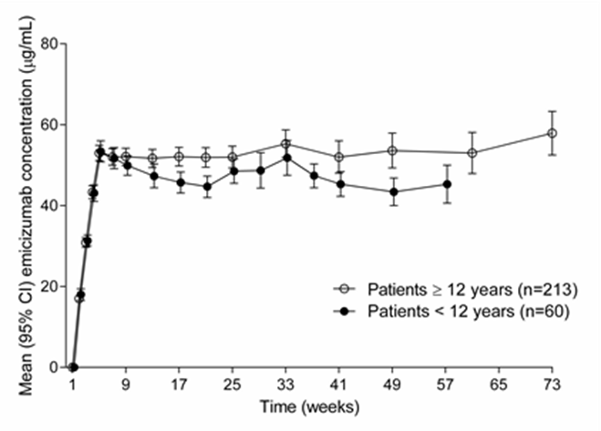

In healthy subjects, the absolute bioavailability following subcutaneous administration of 1 mg/kg was between 80.4% and 93.1% depending on the injection site. Similar pharmacokinetic profiles were observed following subcutaneous administration in the abdomen, upper arm, and thigh. Emicizumab can be administered interchangeably at these anatomical sites (see section 4.2).

Distribution

Following a single intravenous dose of 0.25 mg/kg emicizumab in healthy subjects, the volume of distribution at steady state was 106 mL/kg (i.e. 7.4 L for a 70-kg adult).

The apparent volume of distribution (V/F), estimated from the population PK analysis, in haemophilia A patients following multiple subcutaneous doses of emicizumab was 10.4 L.

Metabolism

The metabolism of emicizumab has not been studied. IgG antibodies are mainly catabolised by lysosomal proteolysis and then eliminated from or reused by the body.

Elimination

Following intravenous administration of 0.25 mg/kg in healthy subjects, the total clearance of emicizumab was 3.26 mL/kg/day (i.e. 0.228 L/d for a 70-kg adult) and the mean terminal half-life was 26.7 days.

Following single subcutaneous injection in healthy subjects, the elimination half-life was approximately 4 to 5 weeks.

Following multiple subcutaneous injections in haemophilia A patients, the apparent clearance was 0.272 L/day and the elimination apparent half-life was 26.8 days.

Dose linearity

Emicizumab exhibited dose-proportional pharmacokinetics in patients with haemophilia A after the first dose of Hemlibra over a dose range from 0.3 to 6 mg/kg . The exposure (C_{avg, ss}) of multiple doses is comparable between 1.5 mg/kg every week, 3mg/kg every 2 weeks and 6mg/kg dose every 4 weeks.

Special populations

Paediatric

The effect of age on the pharmacokinetics of emicizumab was assessed in a population pharmacokinetic analysis which included 5 infants (≥ 1 month to < 2 years), 55 children (less than 12 years) and 50 adolescents (12 to < 18 years) with haemophilia A. Age did not affect the pharmacokinetics of emicizumab in paediatric patients.

Elderly

The effect of age on the pharmacokinetics of emicizumab was assessed in a population pharmacokinetic analysis which included thirteen subjects aged 65 years and older (no subjects were older than 77 years of age). Relative bioavailability decreased with older age, but no clinically important differences were observed in the pharmacokinetics of emicizumab between subjects < 65 years and subjects ≥ 65 years.

Race

Population pharmacokinetics analyses in patients with haemophilia A showed that race did not affect the pharmacokinetics of emicizumab. No dose adjustment is required for this demographic factor.

Renal impairment

No dedicated studies of the effect of renal impairment on the pharmacokinetics of emicizumab have been conducted.

Most of the patients with hemophilia A in the population pharmacokinetic analysis had normal renal function (N = 332; creatinine clearance [CLcr] ≥ 90 mL/min) or mild renal impairment (N = 27; CLcr of 60-89 mL/min). Mild renal impairment did not affect the pharmacokinetics of emicizumab. There are limited data available on the use of Hemlibra in patients with moderate renal impairment (only 2 patients with CLcr of 30-59 mL/min) and no data in patients with severe renal impairment. The impact of moderate and severe renal impairment on the pharmacokinetics of emicizumab cannot be concluded.

Emicizumab is a monoclonal antibody and is cleared via catabolism rather than renal excretion and a change in dose is not expected to be required for patients with renal impairment.

Hepatic impairment

No dedicated studies on the effect of hepatic impairment on the pharmacokinetics of emicizumab have been conducted. Most of the patients with haemophilia A in the population pharmacokinetic analysis had normal hepatic function (bilirubin and AST ≤ ULN, N = 300) or mild hepatic impairment (bilirubin ≤ ULN and AST > ULN or bilirubin from 1.0 to 1.5 × ULN and any AST, N = 51). Only 6 patients had moderate hepatic impairment (1.5 × ULN < bilirubin ≤ 3 × ULN and any AST). Mild hepatic impairment did not affect the pharmacokinetics of emicizumab (see section 4.2). The safety and efficacy of emicizumab have not been specifically tested in patients with hepatic impairment. Patients with mild and moderate hepatic impairment were included in clinical trials. No data are available on the use of Hemlibra in patients with severe hepatic impairment.

Emicizumab is a monoclonal antibody and cleared via catabolism rather than hepatic metabolism and a change in dose is not expected to be required for patients with hepatic impairment.

Other special populations

Modelling shows that less frequent dosing in patients with hypoalbuminemia and low body weight for their age results in lower emicizumab exposures; simulations indicate that these patients would still benefit from clinically meaningful bleed control. No patients with such characteristics were enrolled in clinical trials.

5.3 Preclinical safety data

Preclinical data reveal no special hazards for humans based on studies of acute and repeated dose toxicity, including safety pharmacology endpoints and endpoints for reproductive toxicity.

Fertility

Emicizumab did not cause any changes in the reproductive organs of male or female cynomolgus monkeys up to the highest tested dose of 30 mg/kg/week (equivalent to 11 times the human exposure at the highest dose of 3 mg/kg/week, based on AUC).

Teratogenicity

No data are available with respect to potential side effects of emicizumab on embryo-foetal development.

Injection site reactions

Reversible hemorrhage, perivascular mononuclear cell infiltration, degeneration/necrosis of subcutis and swelling of endothelium in the subcutis was noted in animals after subcutaneous injection.

6. PHARMACEUTICAL PARTICULARS

6.1 List of excipients

L-Arginine
L-Histidine
L-Aspartic acid
Poloxamer 188
Water for injections

6.2 Incompatibilities

No incompatibilities between Hemlibra and polypropylene or polycarbonate syringes and stainless steel needles have been observed.

In the absence of compatibility studies, this medicinal product must not be mixed with other medicinal products.

6.3 Shelf life

Unopened vial

Do not use this medicine after the expiry date ("EXP") stated on the container

Once removed from the refrigerator, unopened vials can be kept at room temperature (below 30°C) for up to 7 days.

After storage at room temperature, unopened vials may be returned to the refrigerator. If stored out of and then returned to refrigeration, the total combined time out of refrigeration should not exceed 7 days. The vials should never be exposed to temperatures above 30 °C. Vials that have been kept at room temperature for more than 7 days or exposed to temperatures above 30 °C should be discarded.

Pierced vial and filled syringe

From a microbiological point of view, once transferred from the vial to the syringe, the medicinal product should be used immediately. If not used immediately, in-use storage times and conditions are the responsibility of the user.

6.4 Special precautions for storage

Store in a refrigerator (2°C to 8°C).

Do not freeze.

Keep the vial in the outer carton in order to protect from light.

For storage conditions after first opening of the medicinal product, see section 6.3.

6.5 Nature and contents of container

Hemlibra 30 mg/mL solution for injection

3 mL clear glass type I vial with butyl rubber stopper laminated with a fluoro-resin film and crimped with an aluminium cap fitted with a plastic flip-off disk. Each vial contains 30 mg emicizumab in 1 mL of solution for injection. Each carton contains one vial.

Hemlibra 150 mg/mL solution for injection

3 mL clear glass type I vial with butyl rubber stopper laminated with a fluoro-resin film and crimped with an aluminium cap fitted with a plastic flip-off disk. Each vial contains 60 mg emicizumab in 0.4 mL of solution for injection. Each carton contains one vial.

3 mL clear glass type I vial with butyl rubber stopper laminated with a fluoro-resin film and crimped with an aluminium cap fitted with a plastic flip-off disk. Each vial contains 105 mg emicizumab in 0.7 mL of solution for injection. Each carton contains one vial.

3 mL clear glass type I vial with butyl rubber stopper laminated with a fluoro-resin film and crimped with an aluminium cap fitted with a plastic flip-off disk. Each vial contains 150 mg emicizumab in 1 mL of solution for injection. Each carton contains one vial.

Not all pack sizes may be marketed.

6.6 Special precautions for disposal and other handling

Hemlibra solution is a sterile, preservative-free, and ready to use solution for subcutaneous injection that does not need to be diluted.

Hemlibra should be inspected visually to ensure there is no particulate matter or discolouration prior to administration. Hemlibra is a colourless to slightly yellow solution. The solution should be discarded if particulate matter is visible or product is discoloured.

Do not shake.

Hemlibra solution for injection vials are for single-use only.

A syringe, a transfer needle and an injection needle are needed to withdraw Hemlibra solution from the vial and inject it subcutaneously.

Please see below recommended features:

A 1 mL syringe should be used for an injection up to 1 mL of Hemlibra solution, whereas a 2 to 3 mL syringe should be used for an injection greater than 1 mL and up to 2 mL.

Refer to the Hemlibra “Instructions for Use” for handling instructions when combining vials in a syringe. Different Hemlibra vial concentrations (30 mg/mL and 150 mg/mL) should not be combined in a single injection to administer the prescribed dose.

1 mL syringe

Criteria: Transparent polypropylene or polycarbonate syringe with Luer-lock tip, graduation 0.01 mL.

2 to 3 mL syringe

Criteria: Transparent polypropylene or polycarbonate syringe with Luer-lock tip, graduation 0.1 mL.

Transfer needle with filter

Criteria for transfer needle with filter: Stainless steel with Luer-lock connection, gauge 18 G, length 35 mm (1½″), containing a 5 µm filter and preferably with semi-blunted tip.

Injection needle

Criteria: Stainless steel with Luer-lock connection, gauge 26 G (acceptable range: 25-27 gauge), length preferably 9 mm (3/8″) or maximally 13 mm (½″), preferably including needle safety feature.

Please see section 4.2 and package leaflet (section 7 Instructions for Use), for additional information on administration.

Any unused medicinal product or waste material should be disposed of in accordance with local requirements.

Not all concentrations might be marketed in all countries

This is a medicament
A medicament is a product which affects your health, and its consumption contrary to instructions is dangerous for you.
Follow strictly the doctor’s prescription, the method of use and the instructions of the pharmacist who sold the medicament.
The doctor and the pharmacist are experts in medicine, its benefits and risks.
Do not by yourself interrupt the period of treatment prescribed for you.
Do not repeat the same prescription without consulting your doctor.
Medicine: keep out of reach of children
Council of Arab Health Ministers
Union of Arab Pharmacists
Current at August 2020

Made for F. Hoffmann-La Roche Ltd Basel, Switzerland by:
- Chugai Pharma Manufacturing Co., Ltd, Utsunomiya City, Japan
- Samsung BioLogics Co., Ltd. Incheon, Republic of Korea

The manufacturing site locally registered, and from which the product is imported, is stated on the outer box

7. Instructions for use

Transfer Needle with Filter

(For transfer of HEMLIBRA from vial to syringe)

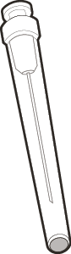

Instructions for Use
Hemlibra
Injection
Single-Dose Vial(s)

You must read, understand and follow the Instructions for Use before injecting Hemlibra. Your healthcare provider should show you how to prepare, measure, and inject Hemlibra properly before you use it for the first time. Ask your healthcare provider if you have any questions.

Important Information:

● Do not inject yourself or someone else unless you have been shown how to by your healthcare provider.

● Make sure the name Hemlibra is on the box and vial label.

● Before opening the vial, read the vial label to make sure you have the correct medicine strength(s) to give the dose prescribed for you. You may need to use more than 1 vial to give yourself the correct dose.

● Check the expiry date on the box and vial label. Do not use if the expiry date has passed.

● Only use the vial once. After you inject your dose, throw away any unused Hemlibra left in the vial. Do not save unused medicine in the vial for later use.

● Only use the syringes, transfer needles and injection needles that your healthcare provider prescribes.

● Use the syringes, transfer needles and injection needles only once. Throw away any used syringes and needles.

● If your prescribed dose is more than 2 mL, you will need to have more than one subcutaneous injection of Hemlibra; contact your healthcare provider for the injection instructions.

● You must inject Hemlibra only under the skin.

Storing Hemlibra vials, needles and syringes:

● Keep the vial in the original box to protect the medicine from light.

● Keep the vials, needles and syringes out of the sight and reach of children. Store the vial in the refrigerator.

● Do not freeze.

● Do not shake the vial.

● Take the vial out of the refrigerator 15 minutes before use and allow it to reach room temperature (below 30°C) before preparing an injection.

● Once removed from the refrigerator, the unopened vial can be kept at room temperature for up to 7 days. After storage at room temperature unopened vials may be returned to the refrigerator. The total amount of time outside cold storage and at room temperature should not exceed 7 days.

● Discard vials that have been kept at room temperature for more than 7 days or have been in temperatures above 30°C.

● Keep the transfer needle, injection needle and syringe dry.

Inspecting the medicine and your supplies:

● Collect all supplies listed below to prepare and give your injection.

● Check the expiry date on the box, on the vial label and on the supplies listed below. Do not use if the expiry date has passed.

● Do not use the vial if:
- the medicine is cloudy, hazy or coloured.
- the medicine contains particles.
- the cap covering the stopper is missing.

● Inspect the supplies for damage. Do not use if they appear damaged or if they have been dropped.

● Place the supplies on a clean, well-lit flat work surface.

INCLUDED IN THE BOX: | 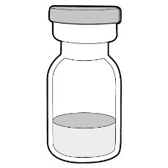 | ● Vial containing the medicine  ● HEMLIBRA Instructions for Use
NOT INCLUDED IN THE BOX: | 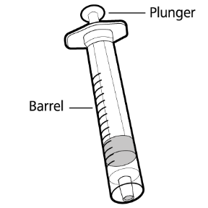  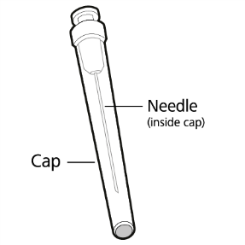  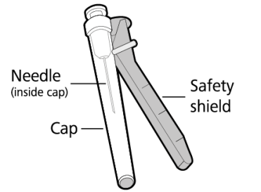  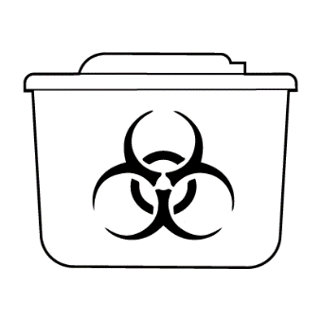 | ● Alcohol wipes  Note: If you need to use more than 1 vial to inject your prescribed dose, you must use a new alcohol wipe for each vial.  ● Gauze  ● Cotton Ball  ● Syringe  Note: For injection amount up to 1 mL use a 1 mL syringe.  For injection amount between 1 mL and 2 mL use a 2 mL or 3 mL syringe.  ● 18G Transfer needle with 5 micrometre filter  Note: If you need to use more than 1 vial to inject your prescribed dose, you must use a new transfer needle for each vial.  Do not use the transfer needle to inject the medicine.  ● 26G Injection needle with safety shield  Do not use the injection needle to withdraw medicine from vial.  ● Sharps disposal container

Get ready:  ● Before use, allow the vial(s) to reach room temperature for about 15 minutes on a clean flat surface away from direct sunlight.  ● Do not try to warm the vial by any other way.  ● Wash your hands well with soap and water. | 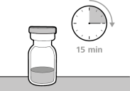  Figure A

Selecting and preparing an injection site:  ● Clean the chosen injection site area using an alcohol wipe.  ● Let the skin dry for about 10 seconds. Do not touch, fan or blow on the cleaned area before your injection.  For injection, you can use your:  ● Thigh (front and middle).  ● Stomach area (abdomen), except for 5 cm around the navel (belly button).  ● Outer area of the upper arm (only if a caregiver is giving the injection).  ● You should use a different injection site for each injection, at least 2.5 cm away from the area you used for your previous injection.  ● Do not inject into areas that could be irritated by a belt or waistband. Do not inject into moles, scars, bruises, or areas where the skin is tender, red, hard or the skin is broken. | 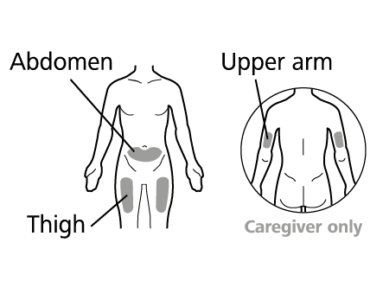  Figure B

Preparing the syringe for injection:
● Do not touch exposed needles or place them on a surface once the cap has been removed.

● Once the syringe has been filled with the medicine, the injection must be given immediately.

● Once the injection needle cap has been removed, the medicine in the syringe must be injected under the skin within 5 minutes. Do not use the syringe if the needle touches any surface.

● Throw away any used vial(s), needles, vial or injection needle caps and used syringes in a sharps or puncture-proof container.

Important information after the injection:

● Do not rub the injection site after injection.

● If you see drops of blood at the injection site, you can press a sterile cotton ball or gauze over the injection site for at least 10 seconds, until bleeding has stopped.

● If you have bruising (small area of bleeding under the skin), an ice pack can also be pressed gently on the site. If bleeding does not stop, please contact your healthcare provider.

Disposing of the medicine and supplies:

Important: Always keep the sharps disposal container out of reach of children.

● Put your used needles and syringes in a sharps disposal container straight away after use. Do not throw away any loose needles and syringes in your household waste.

● If you do not have a sharps disposal container, you may use a household container that is:
- made of heavy-duty plastic.
- can be closed with a tight-fitting, puncture resistant lid, without sharps being able to come out.
- upright and stable during use.
- leak-resistant.
- properly labelled to warn of hazardous waste inside the container.

● When your sharps disposal container is almost full, you will need to follow your local guidelines for the right way to dispose of your sharps disposal container.

● Do not throw away any used sharps disposal container in your household waste unless your local guidelines permit this. Do not recycle your used sharps disposal container.

- PREPARATION  Step 1. Remove vial cap and clean top  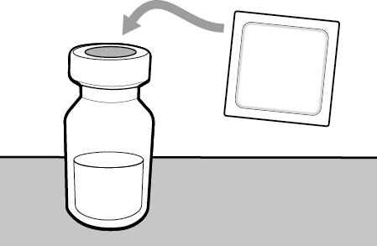 | ● Take the cap off the vial(s).  ● Throw away the vial cap(s) into the sharps disposal container.  ● Clean the top of the vial(s) stopper with an alcohol wipe.
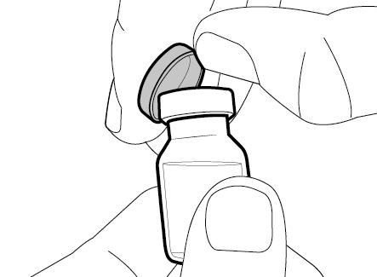
Step 2. Attach transfer needle with filter to syringe  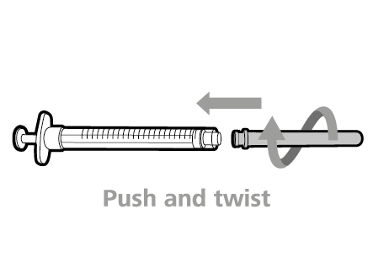  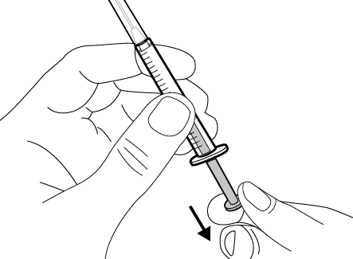 | ● Push and twist the transfer needle with filter clockwise on to the syringe until it is fully attached.  ● Slowly pull back on the plunger and draw air into the syringe that is the same amount as your prescribed dose.

Step 3. Uncap transfer needle  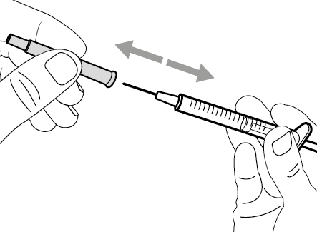 | ● Hold the syringe by the barrel with the transfer needle pointing up.  ● Carefully pull the transfer needle cap straight off and away from your body. Do not throw the cap away. Place the transfer needle cap down on a clean flat surface. You will need to recap the transfer needle after transferring the medicine.  ● Do not touch the needle tip or place it on a surface after the needle cap has been removed.

Step 4. Inject air into vial  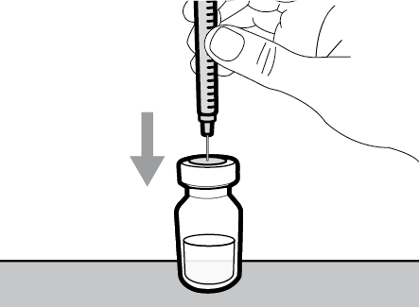  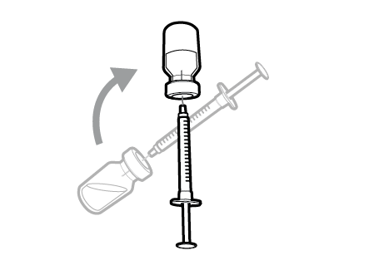  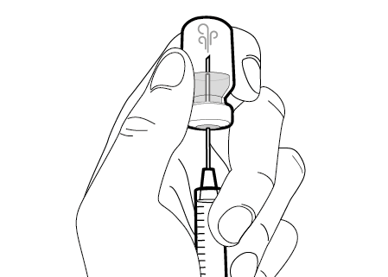 | ● Keep the vial on the flat working surface and insert the transfer needle and syringe straight down into the centre of the vial stopper.  ● Keep the needle in the vial and turn the vial upside down.  ● With the needle pointing upwards, push on the plunger to inject the air from the syringe above the medicine.  ● Keep your finger pressed down on the syringe plunger.  ● Do not inject air into the medicine as this could create air bubbles or foam in the medicine.

Step 5. Transfer medicine to syringe  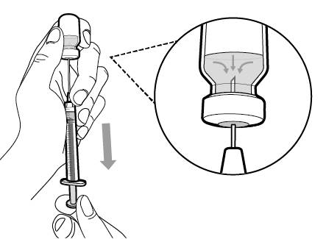 | ● Slide the tip of the needle down so that it is within the medicine.  ● Slowly pull back the plunger to prevent air bubbles/foam.  Fill the syringe with more than the amount of medicine needed for your prescribed dose.  ● Be careful not to pull the plunger out of the syringe.  Important: If your prescribed dose is more than the amount of medicine in the vial, withdraw all of the medicine and go to the “Combining Vials” section now.

Step 6. Remove air bubbles  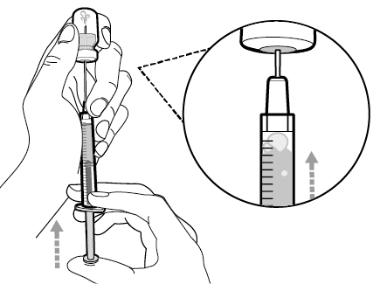  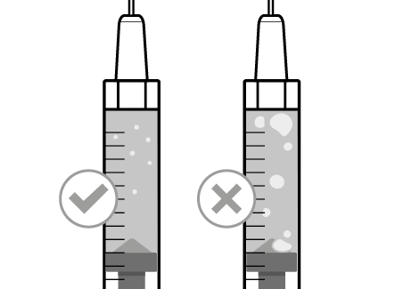 | ● Keep the needle in the vial and check the syringe for larger air bubbles. Large air bubble can reduce the dose you receive.  ● Remove the larger air bubbles by gently tapping the syringe barrel with your fingers until the air bubbles rise to the top of the syringe. Move the tip of the needle above the medicine and slowly push the plunger up to push the air bubbles out of the syringe.  ● If the amount of medicine in the syringe is now at or below your prescribed dose, move the tip of the needle to within the medicine and slowly pull back the plunger until you have more than the amount of medicine needed for your prescribed dose.  ● Be careful not to pull the plunger out of the syringe.  ● Repeat the steps above until you have removed the larger air bubbles.  Note: Ensure you have enough medicine in the syringe to complete your dose before moving onto the next step. If you cannot remove all medicine, turn the vial upright to reach the remaining amount
Do not use the transfer needle to inject medicine as this may cause pain and bleeding.

2. INJECTION  Step 7. Recap transfer needle  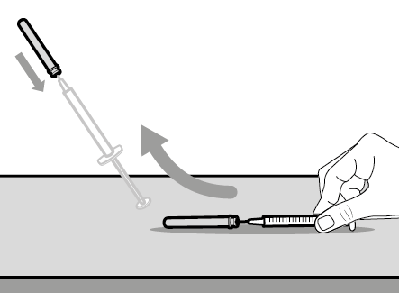 | ● Remove the syringe and transfer needle from the vial.  ● Using one hand, slide the transfer needle into the cap and scoop upwards to cover the needle.  ● Once the needle is covered, push the transfer needle cap towards the syringe to fully attach it with one hand to prevent accidentally injuring yourself with the needle.
Step 8. Clean injection site | ● Select and clean your injection site with an alcohol wipe.

Step 9. Remove transfer needle  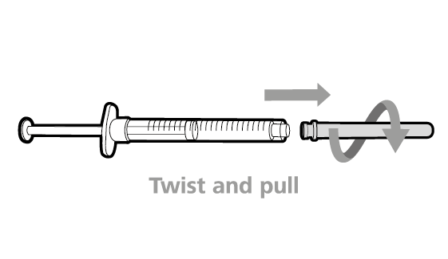 | ● Remove the transfer needle from the syringe by twisting anticlockwise and gently pulling.  ● Throw away the used transfer needle into a sharps disposal container.

Step 10. Attach injection needle to syringe  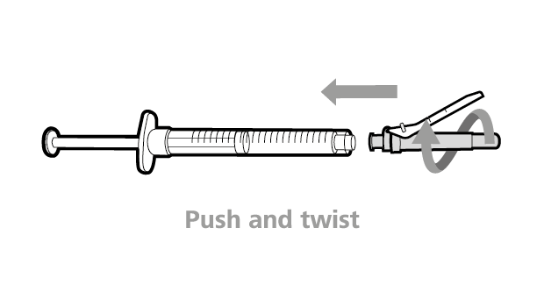 | ● Push and twist the injection needle clockwise onto the syringe until it is fully attached.

Step 11. Move safety shield  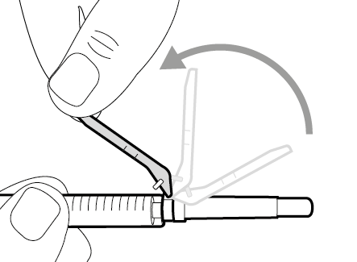 | ● Move the safety shield away from the needle and towards the syringe barrel.

Step 12. Uncap injection needle  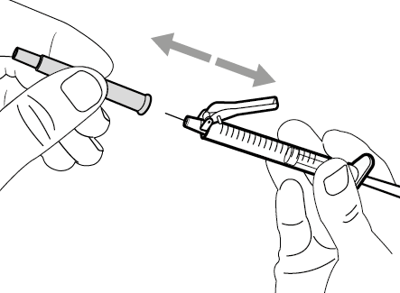 | ● Carefully pull the injection needle cap straightaway from the syringe.  ● Throw away the cap into a sharps disposal container.  ● Do not touch the needle tip or allow it to touch any surface.  ● After the injection needle cap has been removed, the medicine in the syringe must be injected within 5 minutes.
Step 13. Adjust plunger to prescribed dose  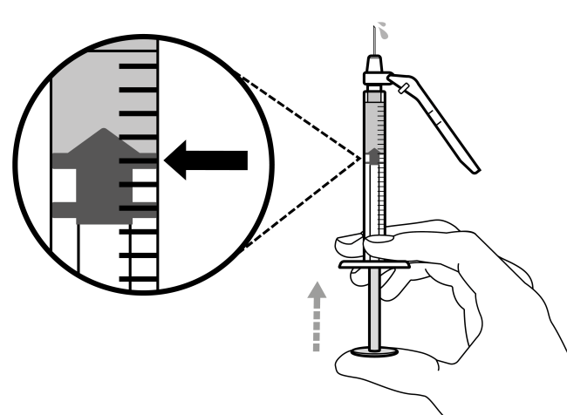 |  | ● Hold the syringe with the needle pointing up and slowly push the plunger to your prescribed dose.  ● Check your dose, ensure the top rim of the plunger is in line with the mark on the syringe for your prescribed dose.

Step 14. Subcutaneous (under the skin) injection  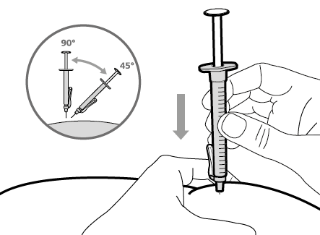 | ● Pinch the selected injection site and fully insert the needle at a 45° to 90° angle with a quick, firm action. Do not hold or push on the plunger while inserting the needle.  ● Hold the position of the syringe and let go of the pinched injection site.  .

Step 15. Inject the medicine  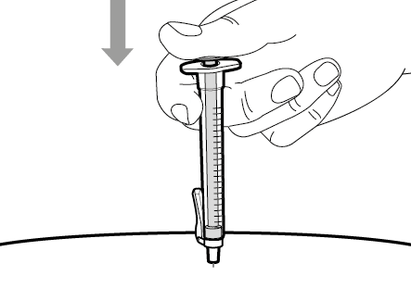 | ● Slowly inject all of the medicine by gently pushing the plunger all the way down.  ● Remove the needle and syringe from the injection site at the same angle as inserted.
3 . DISPOSAL  Step 16. Cover needle with safety shield  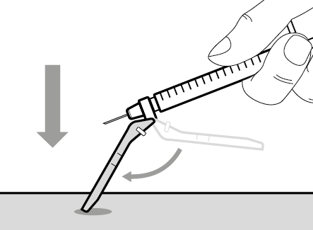  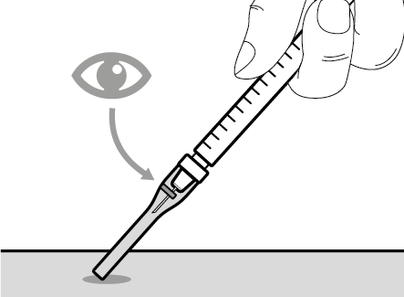 | ● Move the safety shield forward 90°, away from the syringe barrel.  ● Holding the syringe with one hand, press the safety shield down against a flat surface with a firm, quick motion until you hear a “click”.  ● If you do not hear a click, look to see that the needle is fully covered by the safety shield.  ● Keep your fingers behind the safety shield and away from the needle at all times.  ● Do not detach injection needle

Step 17. Throw away the syringe and needle.  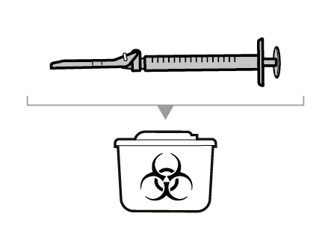 | ● Put your used needles and syringes in a sharps disposal container right away after use. For further information refer to the section “Disposing of the medicine and supplies”.  ● Do not try to remove the used injection needle from the used syringe.  ● Do not recap the injection needle with the cap.  ● Important: Always keep the sharps disposal container out of reach of children.  ● Throw away any used caps, vial(s), needles and syringes in a sharps or puncture-proof container

Combining Vials

If you need to use more than 1 vial to get to your prescribed dose, follow these steps after you have drawn up the medicine from the first vial:

Step A. Recap transfer needle | ● Remove the syringe and transfer needle from the first vial.  ● Using one hand, slide the transfer needle into the cap and scoop upwards to cover the needle.  ● Once the needle is covered, push the transfer needle cap toward the syringe to fully attach it with one hand to prevent accidentally injuring yourself with the needle.

Step B. Remove transfer needle | ● Remove the transfer needle from the syringe by twisting anticlockwise and gently pulling.  ● Throw away the used transfer needle into a sharps disposal container.

Step C. Attach a new transfer needle with filter to syringe  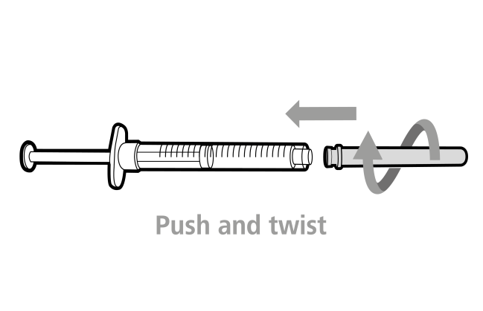 | Note: You must use a new transfer needle with filter each time you withdraw medicine from a new vial.  ● Push and twist a new transfer needle clockwise on to the syringe until it is fully attached.  ● Slowly pull back the plunger and draw some air into the syringe.

Step D. Uncap transfer needle | ● Hold the syringe by the barrel with the transfer needle cap pointing up.  ● Carefully pull the transfer needle cap straight off and away from your body. Do not throw the cap away. You will need to recap the transfer needle after drawing up the medicine.  ● Do not touch the needle tip.

Step E. Inject air into vial | ● With the new vial on the flat working surface, insert the new transfer needle and syringe, straight down into the centre of the vial stopper.  ● Keep the transfer needle in the vial and turn the vial upside down.  ● With the needle pointing upwards, inject the air from the syringe above the medicine.  ● Keep your finger pressed down on the syringe plunger.  ● Do not inject air into the medicine as this could create air bubbles or foam in the medicine.

Step F. Transfer medicine to syringe | ● Slide the tip of the needle down so that it is within the medicine.  ● Slowly pull back the plunger to prevent air bubbles/foam.  Fill the syringe barrel more than the amount of medicine needed for your prescribed dose.  ● Be careful not to pull the plunger out of the syringe.  Note: Ensure you have enough medicine in the syringe to complete your dose before moving onto the next steps. If you cannot remove all medicine, turn the vial upright to reach the remaining amount
Do not use the transfer needle to inject medicine as this may cause harm such as pain and bleeding.

Repeat steps A to F with each additional vial until you have more than your prescribed dose. Once completed, keep the transfer needle inserted in the vial and return to Step 6. Continue with the remaining steps.

